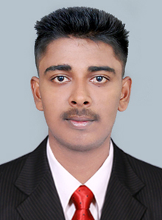
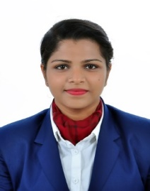
Moolan (H),Chennamangalam P.O
Karimpadam,Ernakulam,Kerala-683512
MOB NO.-+91 8547617683
EMAIL ID – dennydavis887@gmail.com
DENNEY DAVIS

CAREER OBJECTIVE
To accomplish and fulfill my desire to be happy in an environment, which will help me to grow and give me a chance to improve and use my skills for the overall benefit of the organization.

EDUCATIONAL QUALIFICATION
QUALIFICATION | INSTITUTIONS | UNIVERSITY/  BOARD | YEAR OF PASSING | %
B.Sc. HOSPITALITY & HOTEL ADMINISTRATION | ORIENTAL SCHOOL OF HOTEL MANAGEMENT, KERALA. | NCHMCT/  IGNOU | PURSUING | ---
CLASS XII | St Joseph HSS  Koonamavu. | Kerala Board | 2017 | 67%
CLASS X | LFHS  Narakkal. | Kerala Board | 2015 | 79%

INDUSTRIAL EXPOSURE TRAINING
MARRIOT BANGLORE WHITEFIELD.

Trained in: Front office, Housekeeping, Food and Beverage Service & Food production.

AREA OF INTEREST
    - FOOD PRODUCTION
    - FOOD AND BEVERAGE

LANGUAGES KNOWN
    - English
    - Malayalam

ACHIEVEMENTS
- Part of Christofest held in college
- Participated in several events held in college
- Member of Gastronomy Club.

STRENGTHS
- Flexible.
- Honest.
- Confident.
- Positive attitude.
- Punctual & Disciplined.
- Passionate towards work.

PERSONAL DETAIL
Nationality Indian
Sex Male
DOB 23 DECEMBER 1998
Father Name MD DAVIS
Hobbies Playing Cricket, Travelling,
Watching Movies

REFERENCE
MRS. ZUBAIDA NAUSHAD
Head of Department - Front Office
Oriental School of Hotel Management
Lakkidi, Wayanad, Kerala.
MOB: +91 9567552707
Email Id: zuboffice@gmail.com

MR. JOHNSON PAUL
Assistant Professor – Housekeeping
Oriental School of Hotel Management
Lakkidi, Wayanad, Kerala.
MOB: +91 8111955733
Email Id: ietogei@gmail.com

DECLARATION
I hereby declare that the above mentioned information is true and correct to the best of my knowledge and belief.

DATE:

PLACE: (DENNEY DAVIS)

